**Executive Summary**

Proposal for Techopoly Inc.

By Simple Services Inc.

Techopoly has requested bids on their new headquarters located in Dayton, Oh. Simple Services is sending this summary document as a proposed bid for Techopoly to review.

Simple Services is providing a basic solution for Techopoly. It will consist of a network that contains 50 Windows 7 workstations, two webservers, one database server, and three networked printers. The network is behind a firewall and is fed into a 48 port switch. The workstations and printers are connected to the switch by CAT6 cable and the servers are connected by fiber optic cable and backed by a UPS system. The CAT6 cable will be run from the main server room where the servers, switches, and firewall will be located. The workstations will be connected to power surge protected power strips and setup according to Techopoly’s needs.

In this document will be the proposed network diagram and a list of each component along with the cost. The total cost of this proposed network setup is $46,919.63.

**Network Diagram**

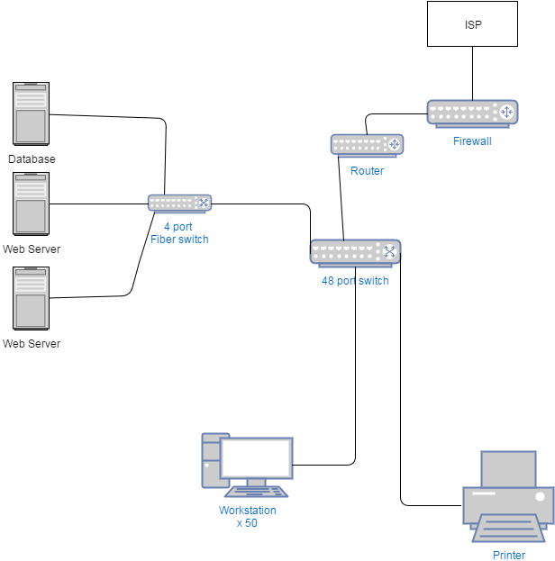

**COST SUMMARY**



**Microsoft Active Directory tree structure**

